**Adaptive Multi-Channel Audio Processor**

**Abstract:**

In music production, audio mixing and mastering are essential processes that allow music to meet standard criteria to be sold in the market. However, those processes are found to be difficult for new producers/artist. This paper would propose an algorithm and approaches to develop/improve adaptive multi-channel audio processor with self-optimization and customisable EQ, pan, and volume. Whilst, the integral improvement of the system is to provide a frequency collision (or masking) identification system (FCIS). Followed by the proposed time frame estimation that is required to complete technology’s development. The expected outcomes from project is to enhance music production efficiency/rate, minimizing long-term production cost, and provide healthy production workflow. Additionally, the technology is expected to create opportunities for new producers/artists in developing experience on mixing/mastering to be actively competitive in the industry.

**Project Justification:**

In the 20th century, mixing and mastering are essential processes that allow music to meet a proper sound quality to be sold in the market (e.g. CD, vinyl, or music streaming platforms). Manipulating audio channels and overall audio output to achieve balance frequency spectrum is the main aim from these processes. Hence, harmless and comfortable music audio frequency on listeners (Daniel 2019). Mixing has an objective to adjust multiple audio channels so that it balances with other existing channels when being collaged/played together. Therefore, it focuses more on complex technical process that requires creative/artistic and perceptive decision making skills (De Man et al. 2015). While mastering is the final step to finalize the overall audio mixes. This will influence music to be louder, while maintaining standard sales audio level (e.g. -1.0 dB). Furthermore, it enhances music to sound different/unique, maintain the consistency of the sound quality across different environments (e.g. stereo, smart phones, and etc.) (Birtchnell 2018). Hence, distribution ready.

However, for such time-consuming processes that expose human ears to wall of sounds in long duration, this event may lead to ear fatigue. The condition where listener will experience multiple symptoms. Those symptoms include temporary hearing sensitivity loss, inner ear pain, “blurry” sounds, and experience stress. Additionally, those symptoms would affect the quality of mixes and master of each processed music. Temporary hearing sensitivity loss affect listener to need of more sound volume which worsen the issue at hand, while “blurry” sounds leads to inaccurate mix/master due non-optimal ear condition. Eventually, these symptoms may lead to ringing phenomenon in human ear (Tinnitus). On the other hand, the time spent for producer/artist to meet a certain level of success in music industry is unknown. Therefore, for new producers, it may lead to high long-term music production cost (hiring mix/master engineer cost $22 – $45 per hour) (PayScale 2020).

**Project Aim:**

To develop an adaptive multiple audio processor that provide clean and balance mix/master, enhances production efficiency, assist user to develop skills/experiences, healthy production process and reduce long-term production cost.

**Project Objectives:**

1. Evaluate abilities of existing adaptive audio processor VST/ plug-ins to develop new algorithm. Followed by collaborative work with professional mix/master engineers.
2. Collecting perceptual evaluation of audio quality (PEAQ) data on multiple music genres (Lo-Fi, Rock, Jazz, etc.) and musical instruments to build plug-in’s pre-sets.
3. Develop mixing/mastering plug-in prototype with robust self-optimization EQ, pan, and volume systems. Additionally, implementing frequency collision (masking) identification system (FCIS) into EQ (mix/master) system.

**Milestone and Tasks:**

1. **Collaboration and evaluation**
2. Connecting with professional mix and master engineers for collaboration.
3. Analyse the requirement for the existing program to meet consumer’s demands.
4. Analyse challenges met by the existing systems.
5. Determine areas that hasn’t been explored by the existing systems.
6. Identify factors (e.g. psychoacoustic data) that affect the system’s ability and sustainability.
7. **Collect and formulate data into proposed model**
8. Conduct PEAQ studies on broader music genres and instruments.
9. Analyse gathered data and refined the current algorithm at hand.
10. **Develop a prototype model**
11. Integrating collected data to build pre-sets
12. Developing I/O algorithm for FCIS inside mastering EQ and to read/apply pre-sets.
13. Develop an adaptive (self-optimization) algorithm for EQ, pan and volume.
14. Testing mix/master quality and process efficiency
15. System documentation

**Project Timeline:**

|  |  |  |  |  |  |  |  |  |  |  |  |  |  |  |  |  |
| --- | --- | --- | --- | --- | --- | --- | --- | --- | --- | --- | --- | --- | --- | --- | --- | --- |
| Task No. | Task Description | Duration  (month) | Start Date | End Date | Oct 2020 | Nov 2020 | Dec 2020 | Jan 2021 | Feb 2021 | Mar 2021 | Apr 2021 | May 2021 | Jun 2021 | Jul 2021 | Aug 2021 | Sep 2021 |
| 1 | *Collaboration and evaluation* | 4 | 16/09/2020 | 16/01/2021 |  |  |  |  |  |  |  |  |  |  |  |  |
| Connecting with professional mix and master engineers for collaboration. | 1 | 16/09/2020 | 16/10/2020 |  |  |  |  |  |  |  |  |  |  |  |  |
| Analyse the requirement for the existing program to meet consumer’s demands. |  | 16/09/2020 | 16/10/2020 |  |  |  |  |  |  |  |  |  |  |  |  |
| Analyse challenges met by the existing systems. | 1 | 16/10/2020 | 16/11/2020 |  |  |  |  |  |  |  |  |  |  |  |  |
| Determine areas that hasn’t been explored by the existing systems. | 1 | 16/11/2020 | 16/12/2021 |  |  |  |  |  |  |  |  |  |  |  |  |
| Identify factors (e.g. psychoacoustic data) that affect the system’s ability and sustainability. | 1 | 16/12/2021 | 16/01/2021 |  |  |  |  |  |  |  |  |  |  |  |  |
| 2 | *Collect and formula data into proposed model* | 3 | 16/10/2020 | 16/01/2020 |  |  |  |  |  |  |  |  |  |  |  |  |
| Conduct PEAQ studies on broader music genres and instruments. | 1 | 16/11/2020 | 16/12/2021 |  |  |  |  |  |  |  |  |  |  |  |  |
| Analyse gathered data and refined the current algorithm at hand. | 1 | 16/12/2021 | 16/01/2021 |  |  |  |  |  |  |  |  |  |  |  |  |
| 3 | *Develop a prototype model* | 9 | 16/01/2021 | 16/09/2021 |  |  |  |  |  |  |  |  |  |  |  |  |
| Integrating collected data to build pre-sets. | 2 | 16/01/2021 | 16/03/2021 |  |  |  |  |  |  |  |  |  |  |  |  |
| Developing I/O algorithm for FCIS inside mastering EQ and to read/apply pre-sets. | 5 | 16/01/2021 | 16/06/2021 |  |  |  |  |  |  |  |  |  |  |  |  |
| Develop an adaptive (self-optimization) algorithm for EQ, pan and volume. | 5 | 16/01/2021 | 16/06/2021 |  |  |  |  |  |  |  |  |  |  |  |  |
| Testing mix/master quality and process efficiency | 3 | 16/06/2021 | 16/08/2021 |  |  |  |  |  |  |  |  |  |  |  |  |
| System documentation | 1 | 16/08/2021 | 16/09/2021 |  |  |  |  |  |  |  |  |  |  |  |  |

**Experimental strategy and Approach:**

Mitigate tasks by collaborative work with professional mix/master engineers and review the abilities of the existing mixing/mastering plug-ins. Followed by gathering information about each engineer’s perceptual approaches toward mixing/mastering. Therefore, patterns or similarities from the gathered information will be utilised as the characteristics to be adopted in the proposed model’s algorithm. It is essential to perform an experiment to explore maximum time duration and sound volume that may cause ear fatigue, where the data will be utilised to build system that prevent user from experiencing ear fatigue. Mimilakis et al. (2013) conducted an PEAQ experiment (audio listening test) to collect score on listener’s preferences towards mastered and un-mastered audio. The method conducted in the experiment is recommended by Reiss (2011) in order to diagnose undesired artefacts in audio production. Testing broader music genres (Lo-Fi, Rock, Jazz, Hip-hop, etc.) and musical instruments with various frequency spectrums would enhance credibility of data. Hence, improved reliability of mixing/mastering pre-sets, self-optimization EQ, and FCIS. Prior to the test, master engineers will provide multiple mastering setups for each tested music genre, while mix engineers will provide mix setups for each tested musical instrument. In the end, thorough PEAQ test, the most optimal mastering and mixing setups will be produced. Therefore, information of the setups is then utilised for plug-in’s built-in pre-sets. The research done by Mimilakis et al. (2013) provide data and algorithm that can be develop/extended, which is to implement adaptive tonal balance enhancement by frequency/pitch tracking for self-optimization EQ in mastering process. Where this concept will be combined with the experimental research data from Ramirez & Reiss (2017) that explore DAE audio analysis on musical instrument. Hence, a self-optimization EQ in mixing process.

**Model Formulation:**

Represented on the right-hand side is the flowchart that represent the model’s algorithm. In **Figure 1**, users are able to choose a plugin’s pre-set mode depending on the needs (mastering or mixing). Hence, enhancing user’s flexibility to mix/master audio based on suitable preferences, where this can be done by either creating new setups or manipulate the existing setups from the chosen pre-set. Furthermore, information for all instruments/channels that utilised the plug-in for mixing will be stored. On the output channel (stereo/master out), the mastering mode/pre-set is expected to be chosen to finalizing the overall mixes. Utilising the stored information, FCIS can be performed and show lists of audio channel pairs where frequency collision (masking) occur. From this point, the self-optimization system implanted inside the EQ will allow EQ from each paired channel to adapt to each other and minimise/avoid masking. Minimising frequency masking will be done by identifying region in each audio’s frequency spectrum where paired instruments emit same frequencies when being played in parallel. Then, the region of those frequencies will be sampled and compressed in one of the paired channel’s EQ depending on which channel that requires more focus. The final process output is customisable mixing/mastering computer/pre-set standard setups. Further improvement of the model will be executed after collecting and analysing data of the model’s performance throughout the testing phase.

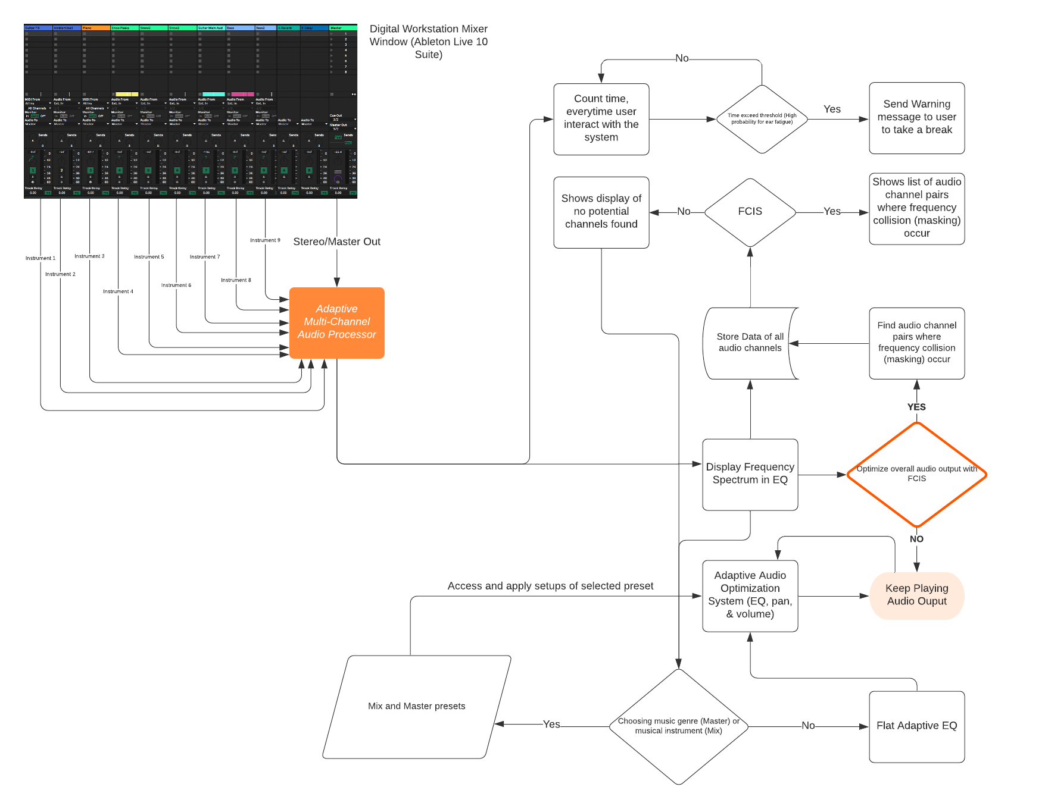

**Figure 1.** Flowchart of model’s algorithm

**Expected Outcomes:**

1. Enhances mixing and mastering workflow (increase production efficiency)
2. Assist new artists/producers to develop skills and experiences in mix/mastering processes. Hence, supporting artist to stay competitive in the industry.
3. Reduce music production cost in long term.
4. Provide healthy music production methodology.

**References:**

Birtchnell, T., 2018. Listening without ears: Artificial intelligence in audio mastering. Big Data & Society, 5(2), p.205395171880855.

De Man, B., Boerum, M., Leonard, B., King, R., Massenburg, G. and Reiss, J., 2015. Perceptual Evaluation of Music Mixing Practices. 138th Audio Engineering Society convention 2015, 1(9235), pp.129-136.

Mimilakis, S., Drossos, K., Floros, A. and Katerelos, D., 2013. Automated Tonal Balance Enhancement for Audio Mastering Applications. *AES 134th Convention*,.

Payscale. 2020. *Sound Engineer Hourly Pay In Australia | Payscale*. [online] Available at: <https://www.payscale.com/research/AU/Job=Sound_Engineer/Salary> [Accessed 7 August 2020].

Ramirez, M., and Reiss, J., 2017. Deep Learning and Intelligent Audio Mixing. *Proceedings of the 3rd Workshop on Intelligent Music Production*

Reiss, J., 2011. Intelligent systems for mixing multichannel audio. *2011 17th International Conference on Digital Signal Processing (DSP)*,.